Lab Assignment GNS3

Name : Ashutosh soni ID : 2018ucp1465

# Q1) *Set-up different types of following topologies and configure them.*

## *Mesh Topology*

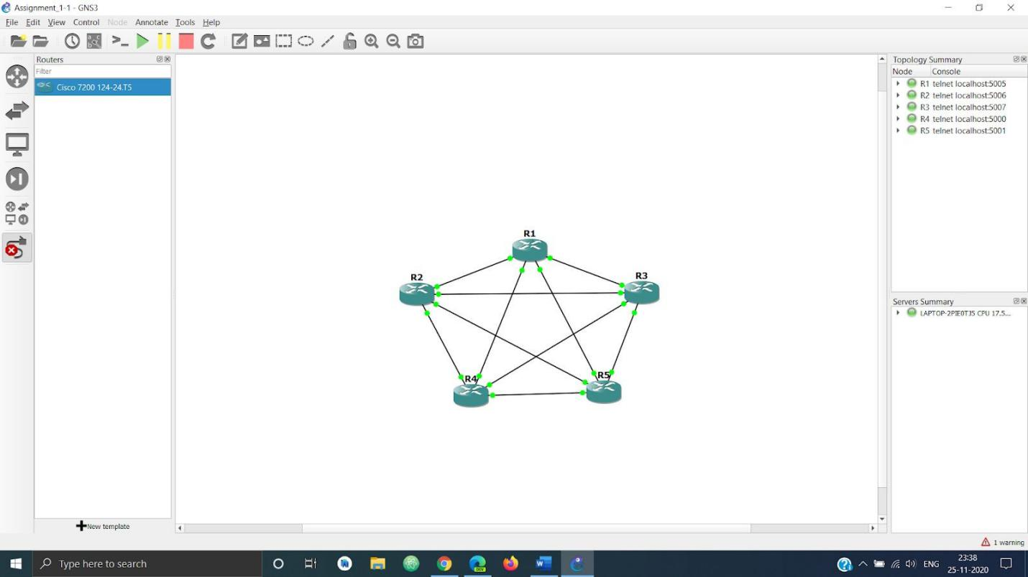

*Star Topology*

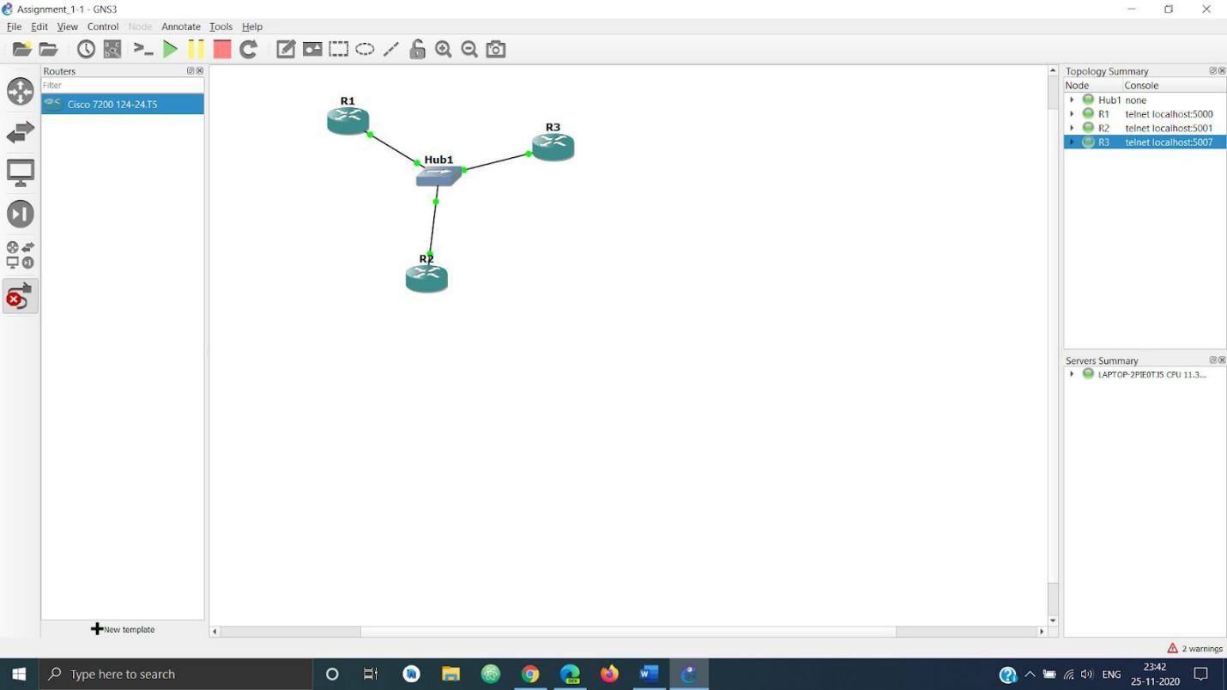

## *Ring Topology*

*Bus Topology*

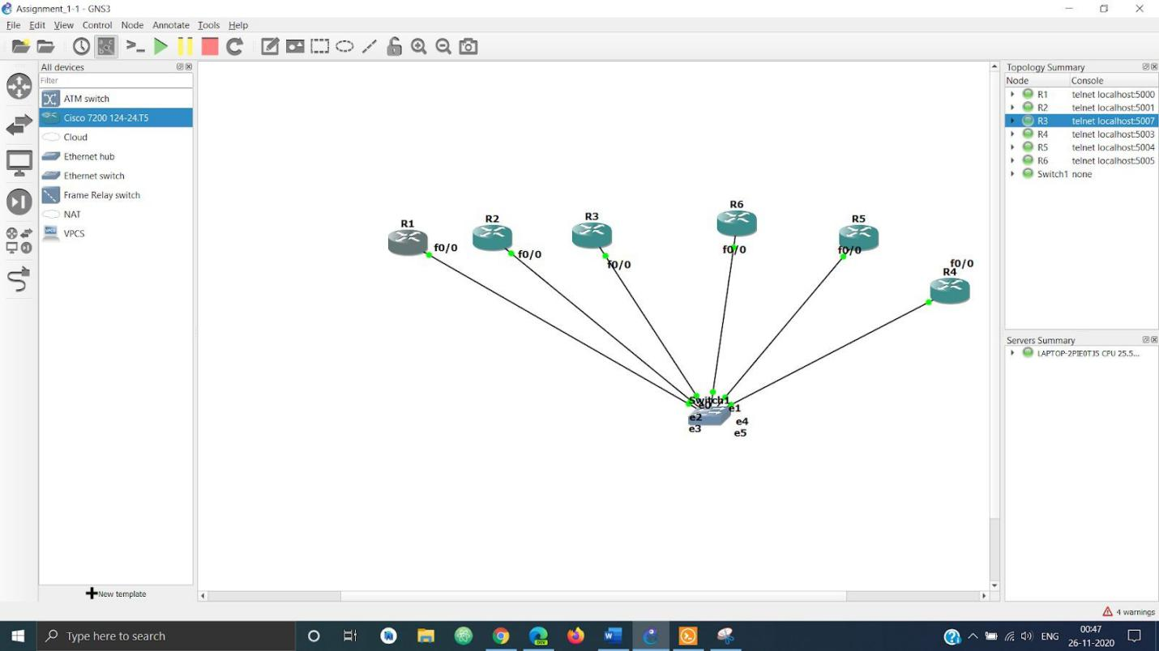

*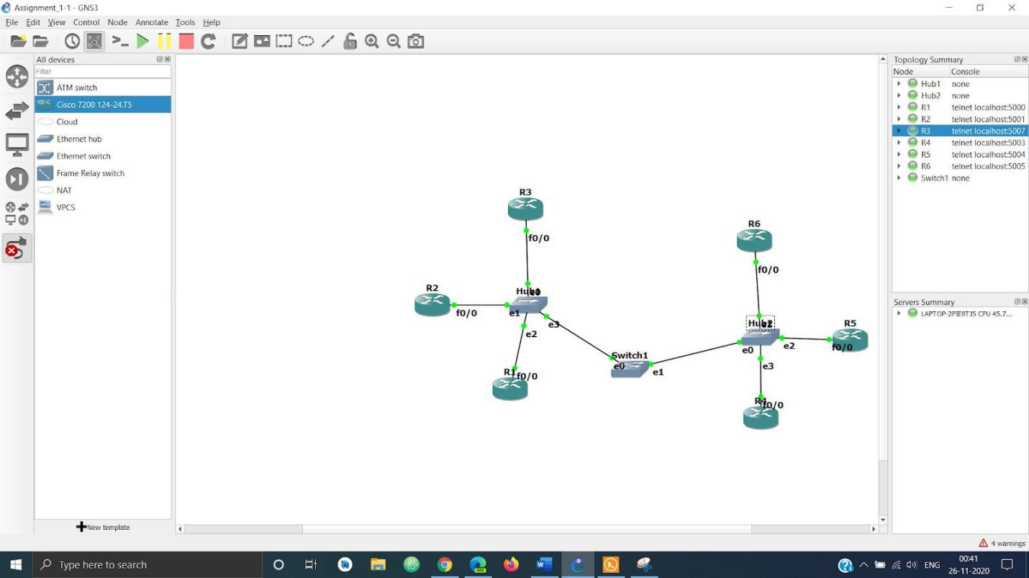Hybrid Topology*

*Q2) In different network topologies*

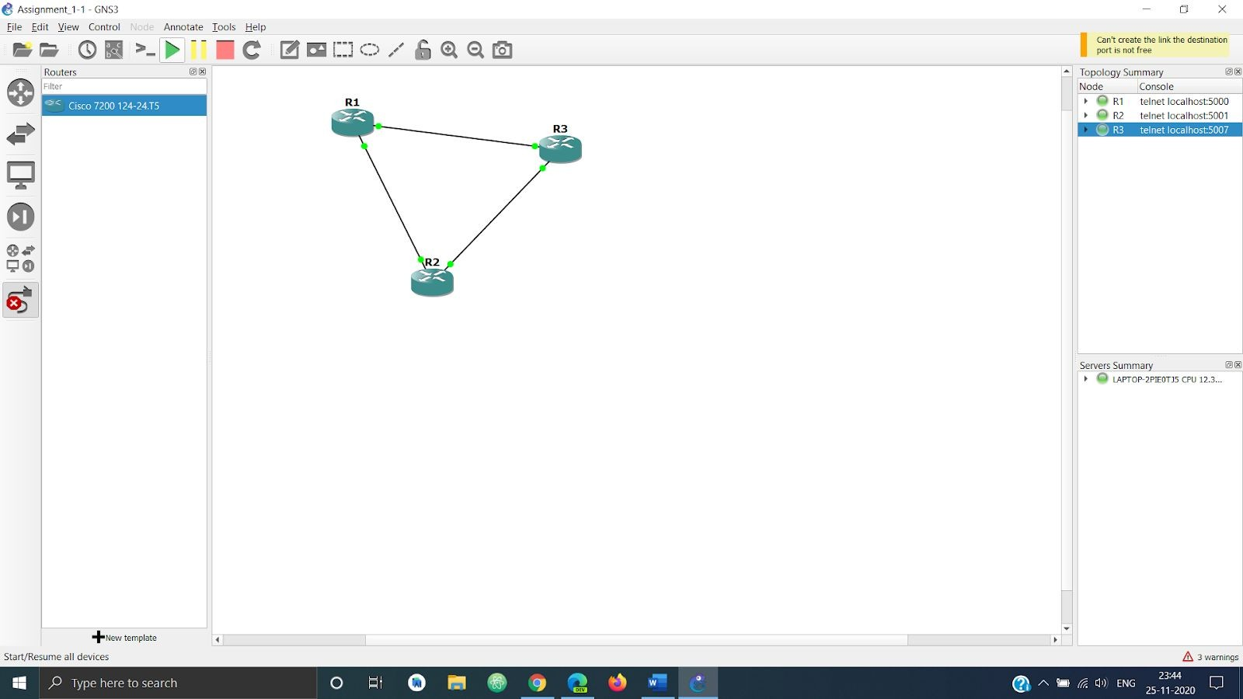

*I am using the above network to showcase all the parts of the question.*

## *Set an Ip address*

*Using the following commands for each router to configure the ip -*

*conf t*

*int FastEthernet No shut*

*Ip add “IP Address”*

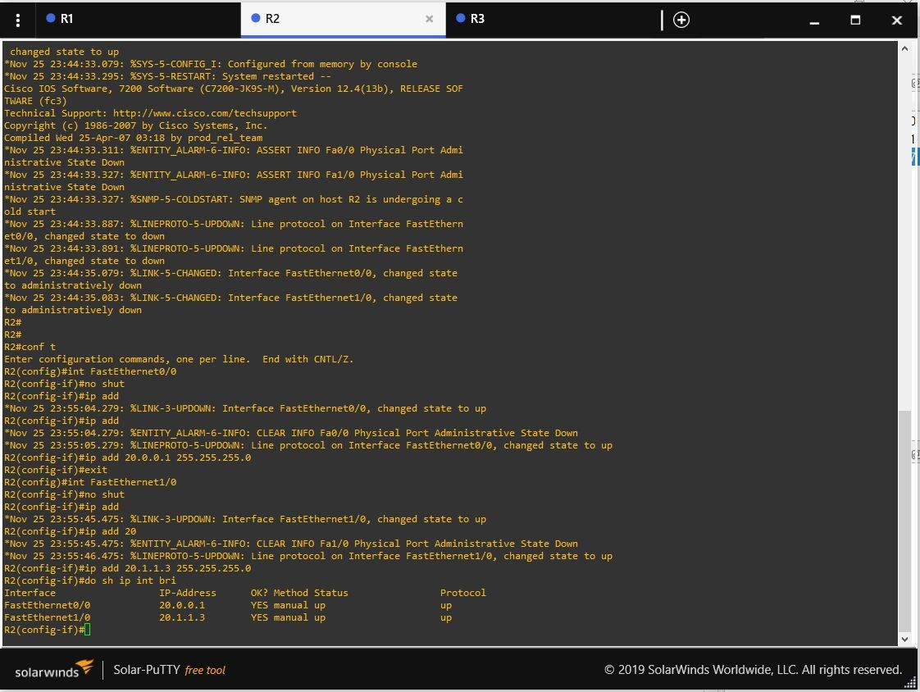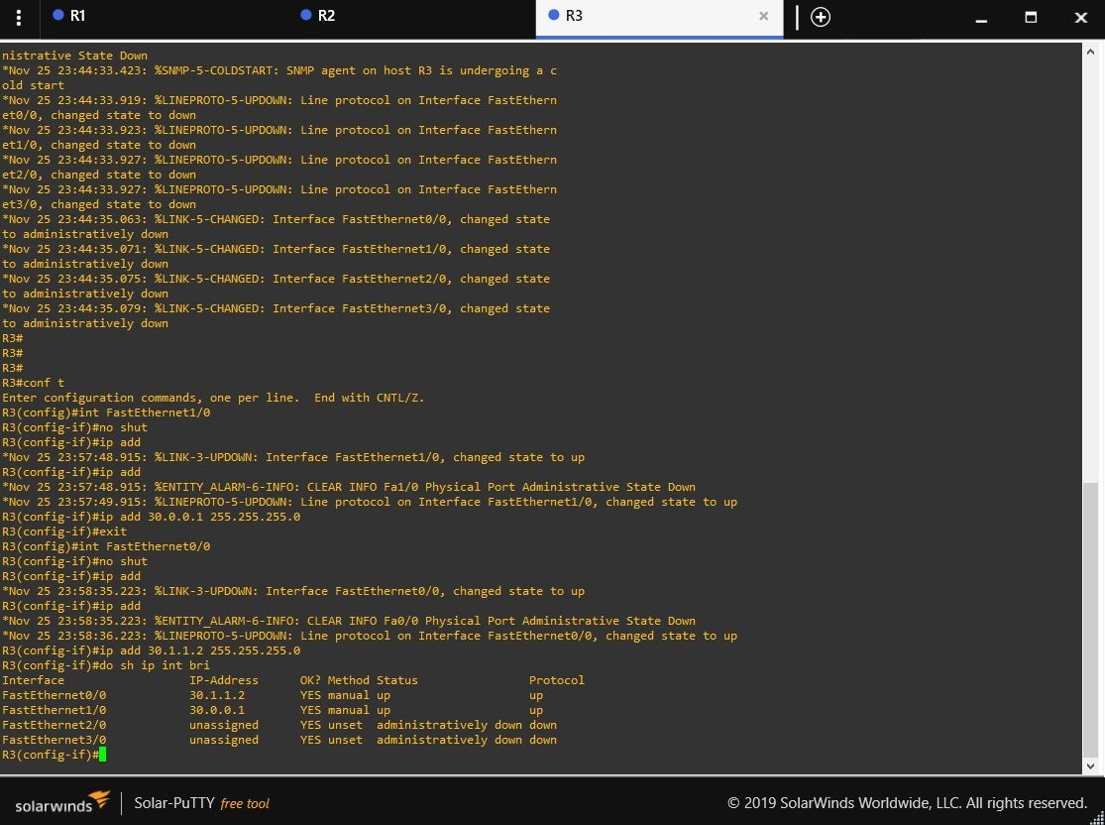

## *Reconfigure network when a node is added*

*Added the Router R4.*

*The following screenshots show the reconfiguration of ips using the commands listed in part a.*

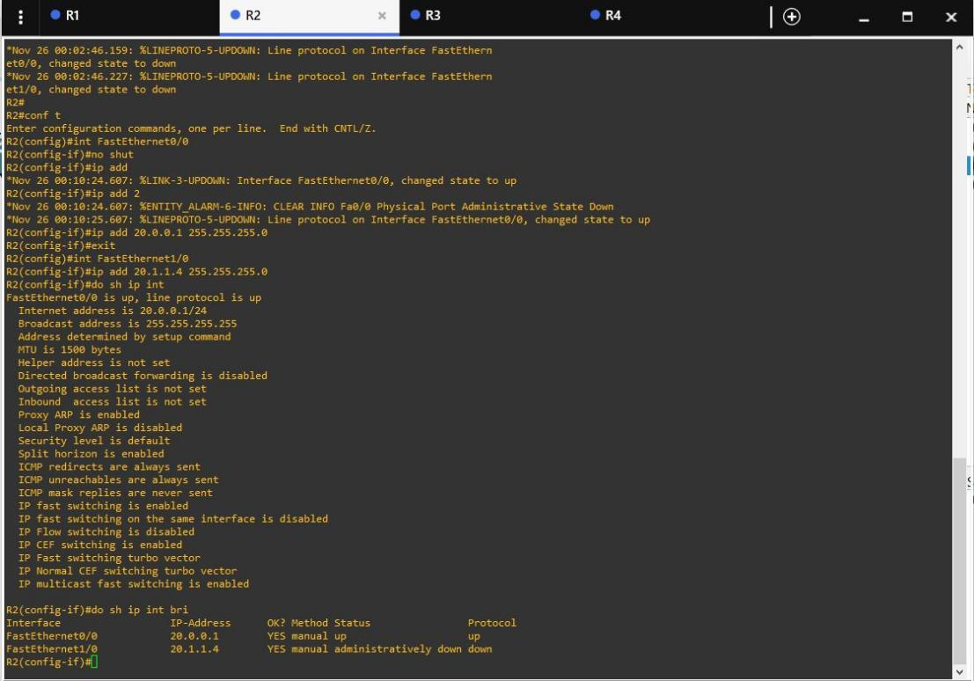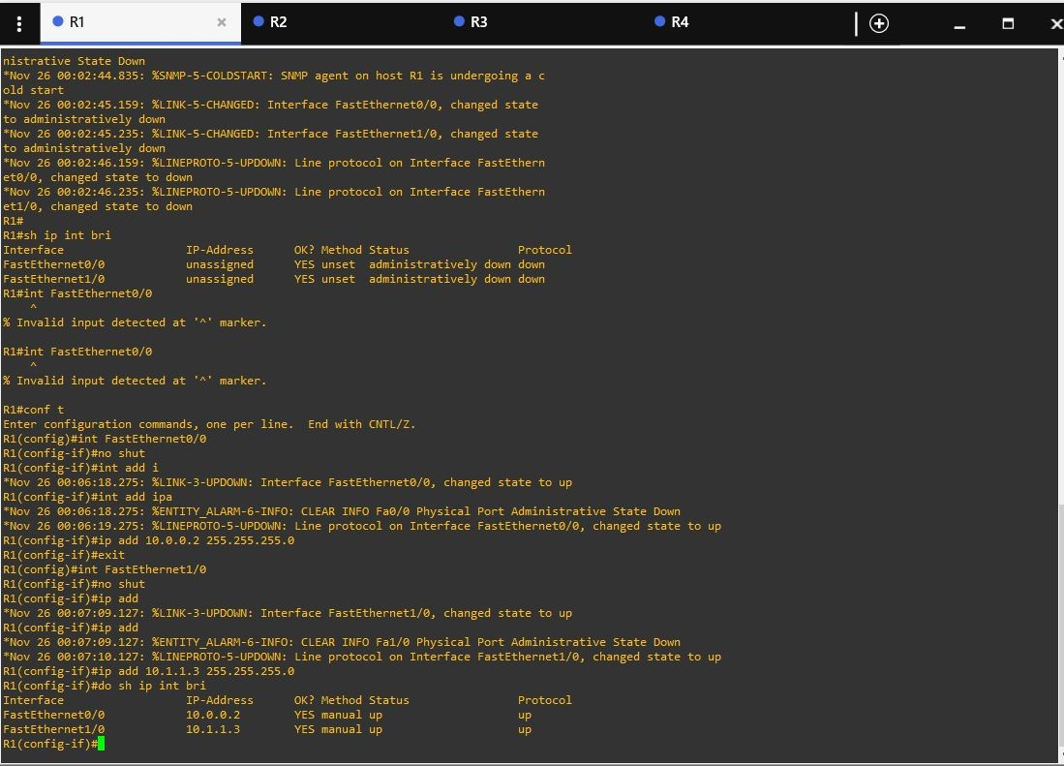

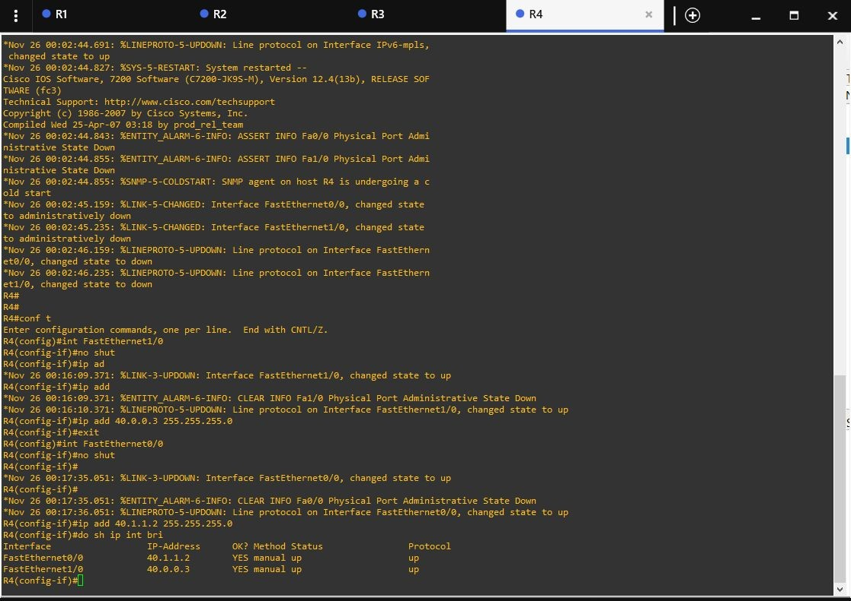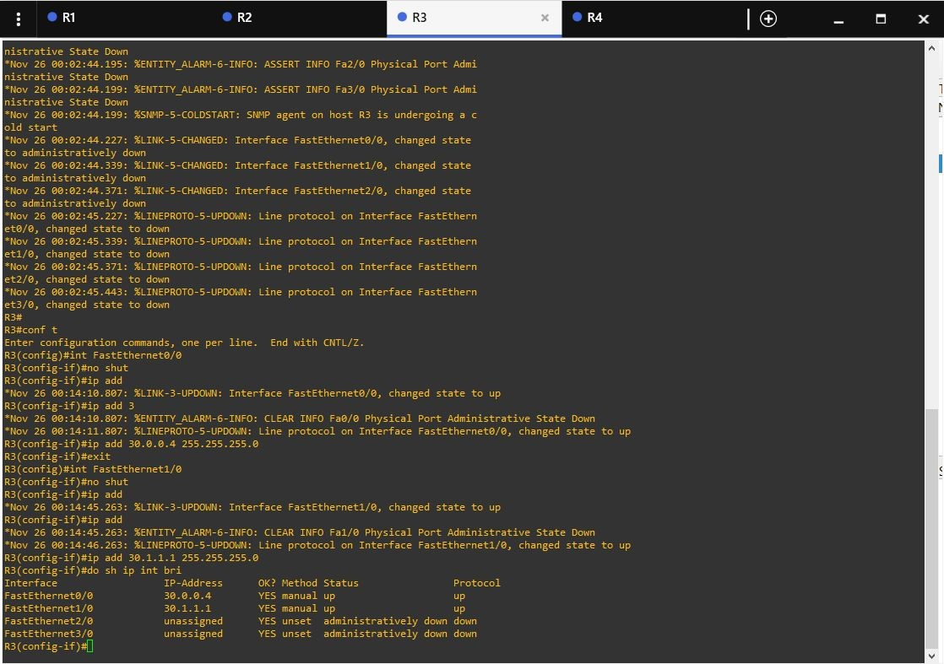

## *Reconfigure network when an existing node is deleted*

*Removed the existing router R4.*

*The following screenshots show the reconfiguration of ips using the commands listed in part a.*

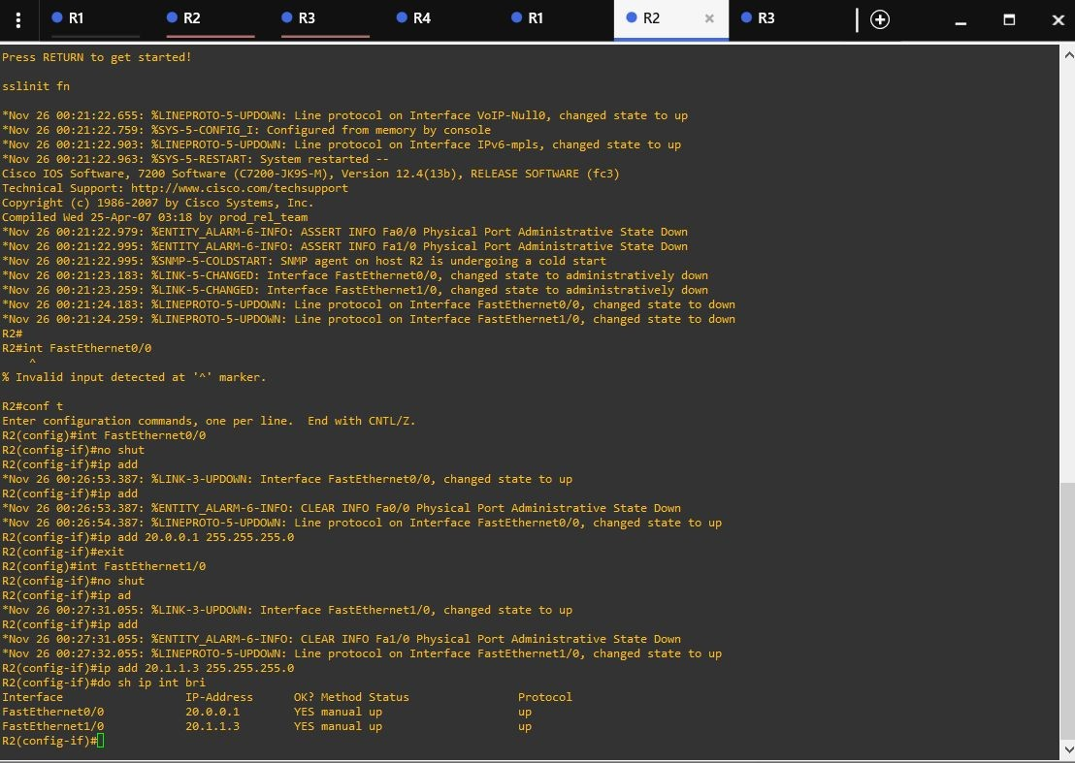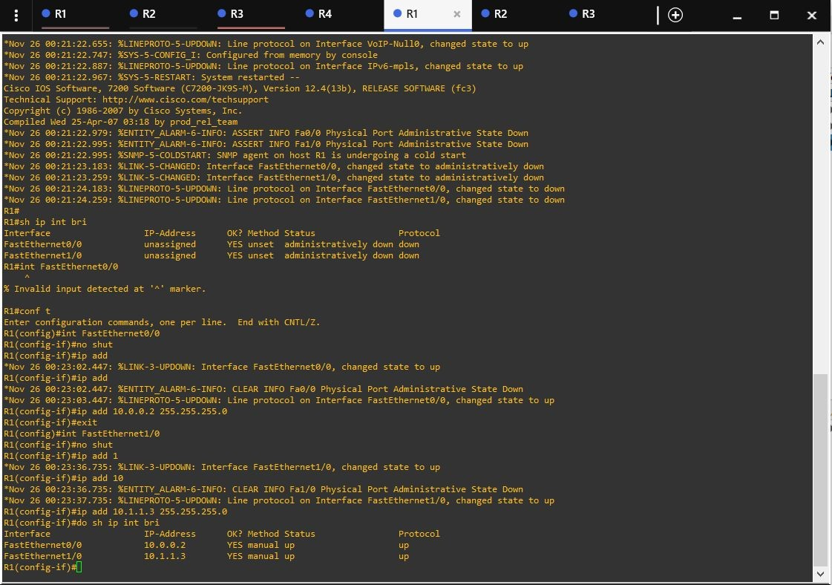

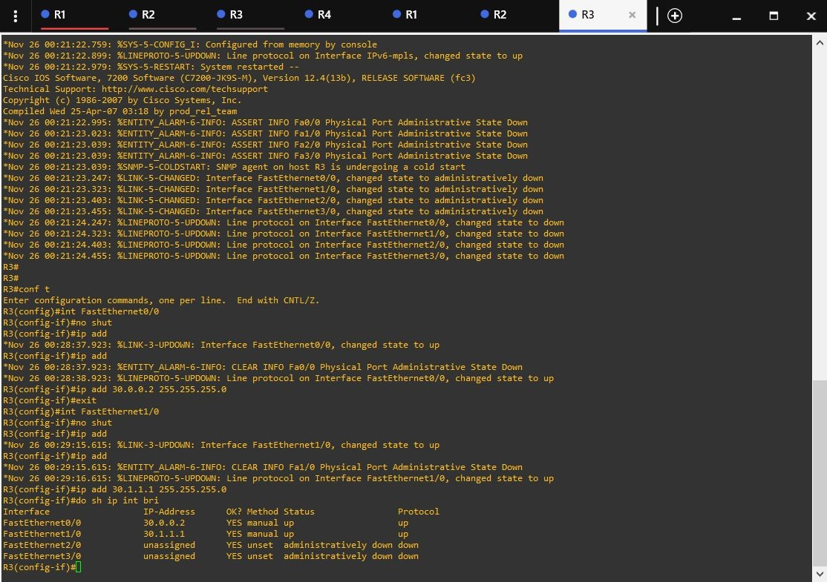

## *Send a packet from one node to another*

*Using the “ping” command to send the packet and check the network.*

## *Identify success and failure rate of transmission*

*The success rate is 100 percent as shown in the above figure, so the failure rate is 0 percent.*

## *Find status and port Number of connected nodes*

*Using the sh ip int bri | e ass command, I am showing all the information regarding the link to R1.*

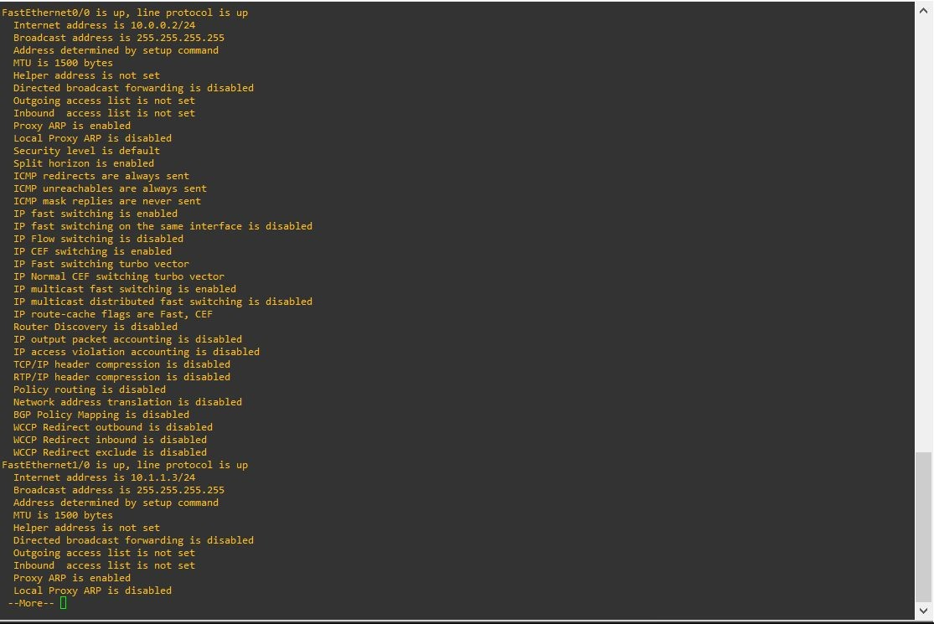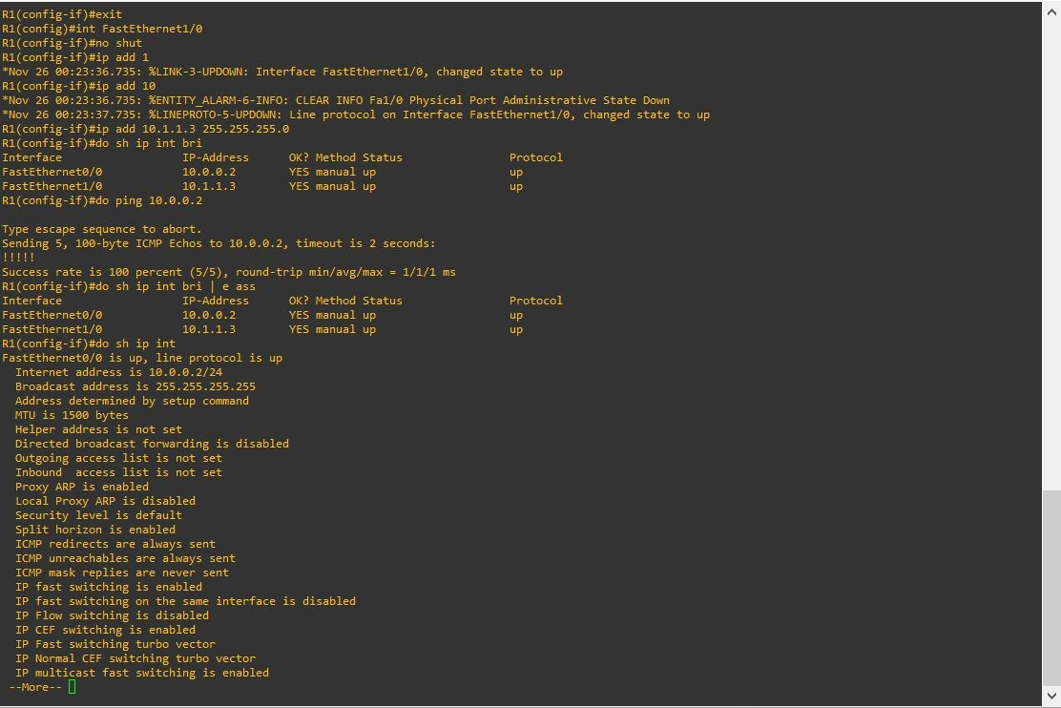

## *Change Ip address of one node and try to communicate*

*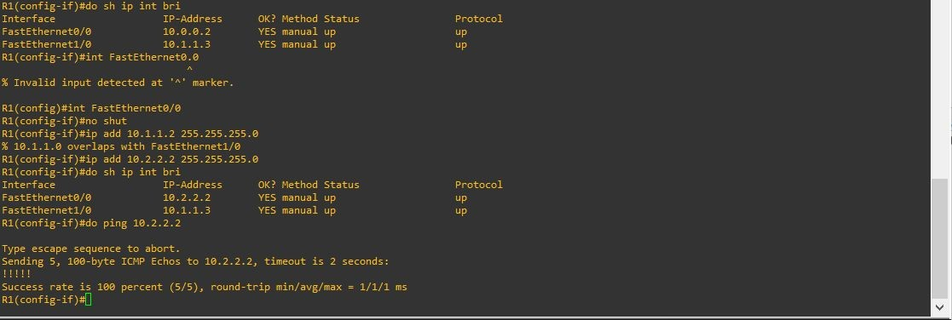Changed the ip address of one node and resend the packet*

# *Q3) Create a client-server architecture and observe communication.*

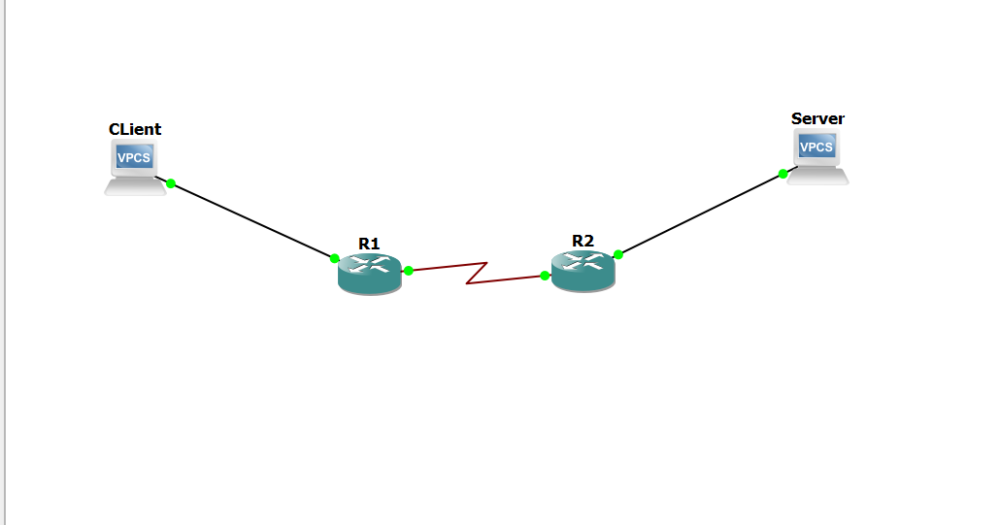

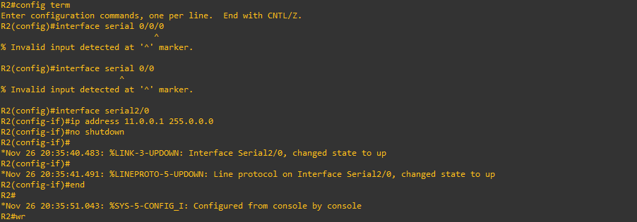

*For router to PC :*

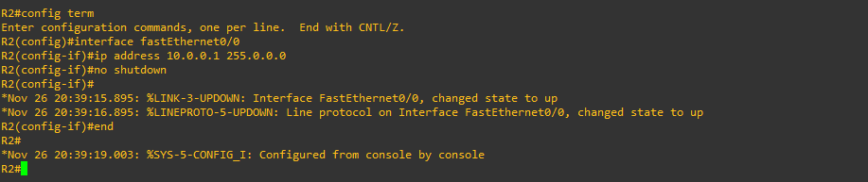

*Wireshark Capture :*

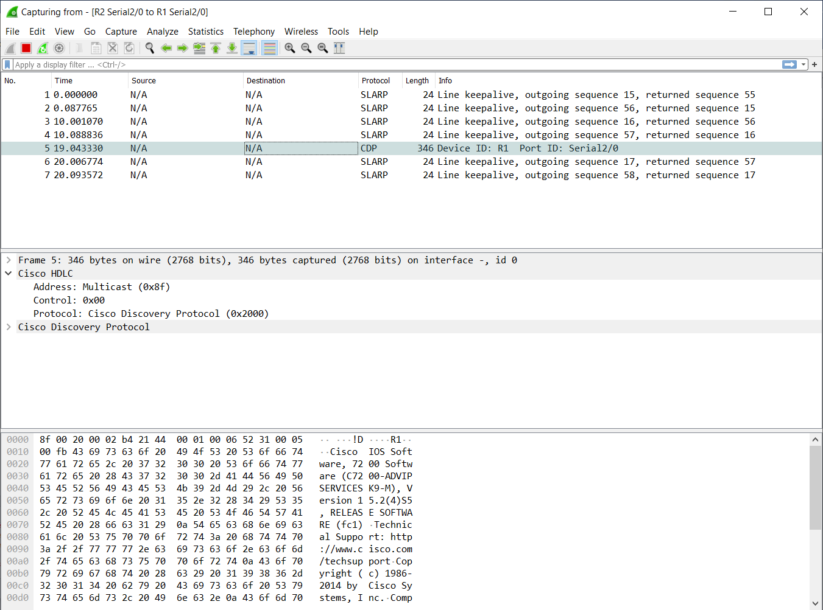

*Q4) Use a single GNS3 GUI to control multiple GNS3 remote servers (GNS3 VMs) running on different physical servers.*

*The below Screenshot shows two router configured on two remote servers (R1 - 198.168.53.240 , R2 - 198.168.43.248) on a single GUI. The Terminal depicts the communication between the routers as R1 is able to ping R2 and vice-a-versa.*

